CAED

Lab#9

Zainab-Binte-Hassan

FA17-BECE-0020

Code1:

m=imread("image.jpg");

m_noise = imnoise(m,'salt & pepper');

imshow(m_noise)

Output:

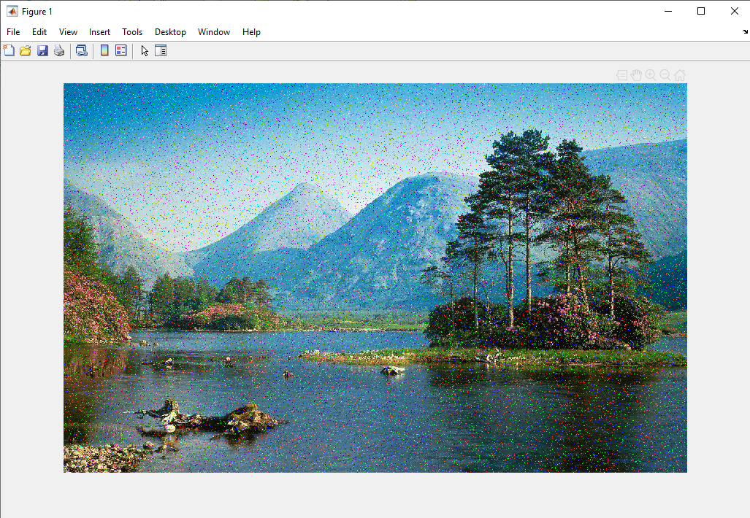

Code2:

x=imread("image.jpg");

x2=rgb2gray(x);

x_noise = imnoise(x2,'gaussian');

imshow(x_noise);

Output:

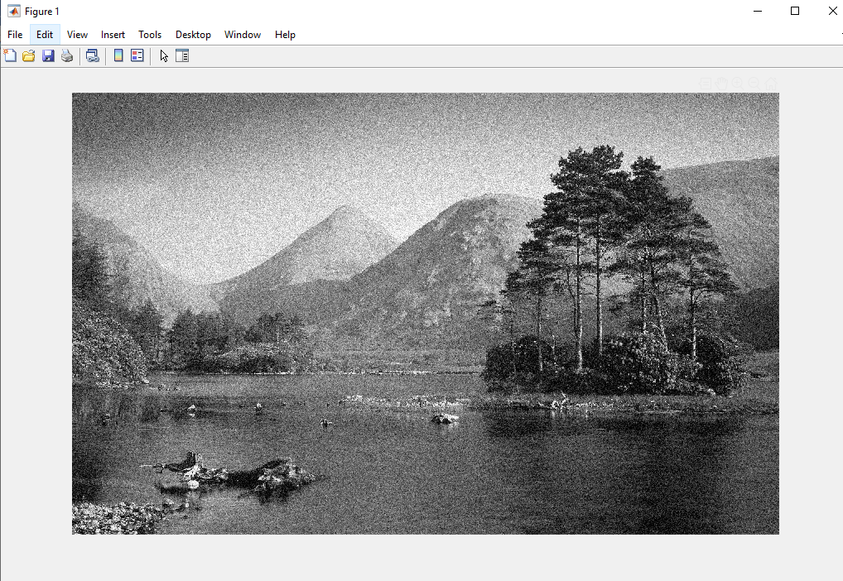

Code3:

z=imread("image.jpg");

z_noise = imnoise(z,'gaussian');

imshow(z_noise);

Output:

